**Client-Side App Rubric** <https://github.com/denisecase/pbl-lifeline-links>

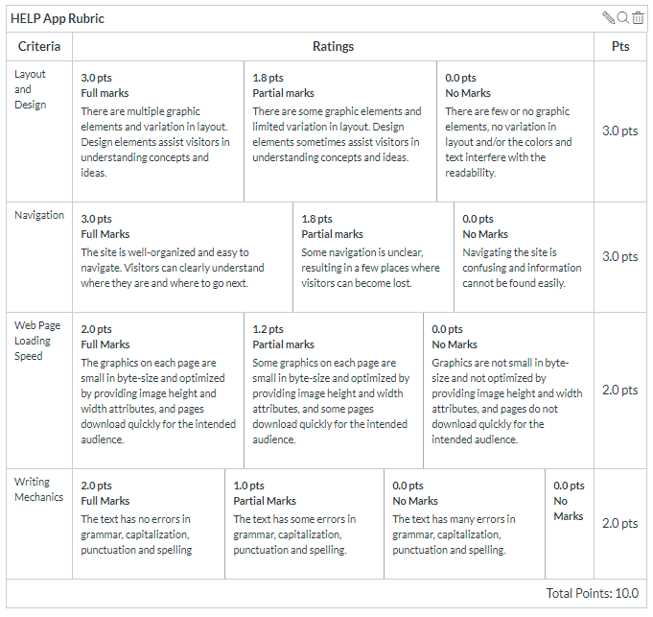

**Team reviewed:** Group 02-08

**Link to the web site:**

<https://suma-gitrep.github.io/help-app/>

**Layout and Design**

Score: 3

Comments:

-The one page layout is working well.

-Color scheme works, high contrast, very clean to read.

-Uses a good amount of pictures, the page loads well.

-Their typography choices look good and are easy to read.

**Navigation**

Score: 3

Comments:

-Easy to navigate.

-User friendly

-Sticky nav is a good option.

**Loading Speed:**

Score: 2

Comments:

-Page loads quickly.

-Limited pictures allow for page to load quickly.

**Writing Mechanics:**

Score: 2

Comments:

-no spelling errors.

**General remarks:**

-overall really user friendly

**Review performed by:**

**Group 4**

**Date and time performed:**

**12/5 12:53pm**